Right Prism
# Source: AI Source: Provided by: [Data Path: Persons Table -> ID Column: 1, Name_En Column: Motasem Essam] -> From: [ChatGPT] on [7/25/2026]
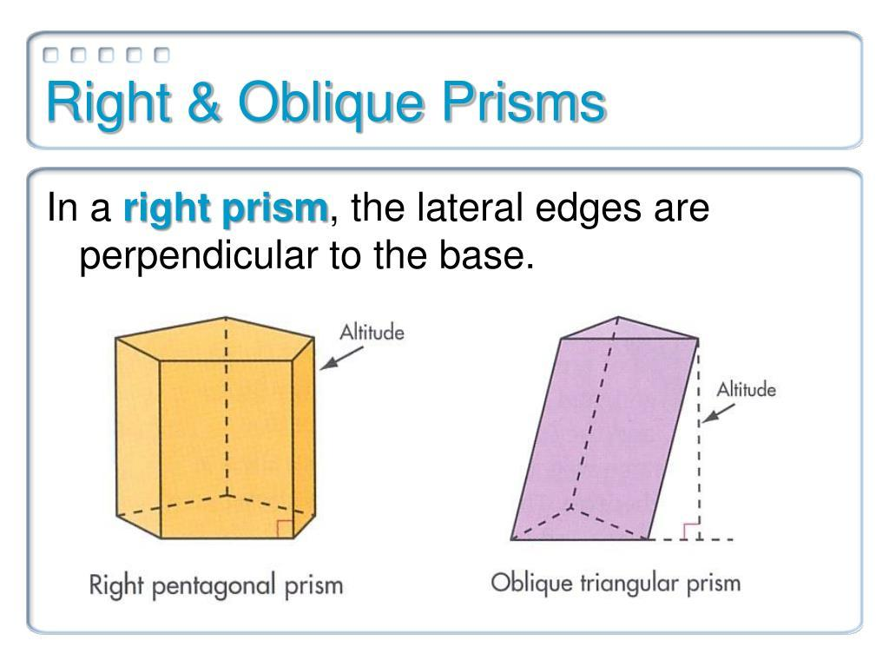
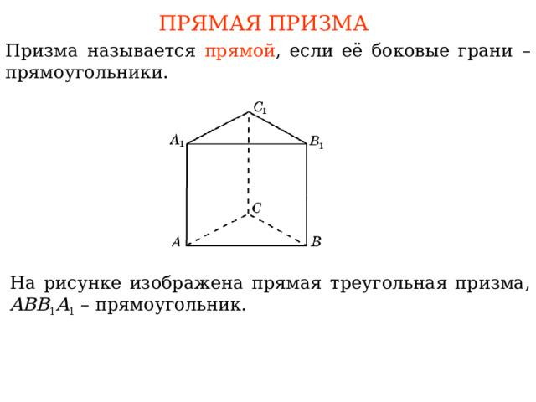
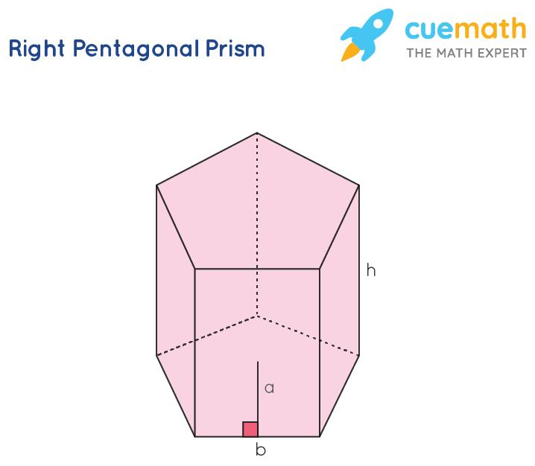

Definition
# Source: AI Source: Provided by: [Data Path: Persons Table -> ID Column: 1, Name_En Column: Motasem Essam] -> From: [ChatGPT] on [7/25/2026]
A right prism is a three-dimensional polyhedron with two congruent, parallel polygonal bases and lateral edges perpendicular to the planes of the bases.
Because the lateral edges meet the bases at right angles, all lateral faces are rectangles.
A right prism can have any polygon as its base, including a triangle, quadrilateral, pentagon, hexagon, or any $n$-sided polygon.
Its defining property is the perpendicular orientation of its lateral edges, rather than the number of sides of its base.

Simple Definition
# Source: AI Source: Provided by: [Data Path: Persons Table -> ID Column: 1, Name_En Column: Motasem Essam] -> From: [ChatGPT] on [7/25/2026]
A right prism is a 3D solid with two identical, parallel polygonal bases joined by straight side edges that meet the bases at ${90}^{∘}$.
Examples include right triangular prisms, right rectangular prisms, and right hexagonal prisms.

Classification Tree
# Source: AI Source: Provided by: [Data Path: Persons Table -> ID Column: 1, Name_En Column: Motasem Essam] -> From: [ChatGPT] on [7/25/2026]
Prisms
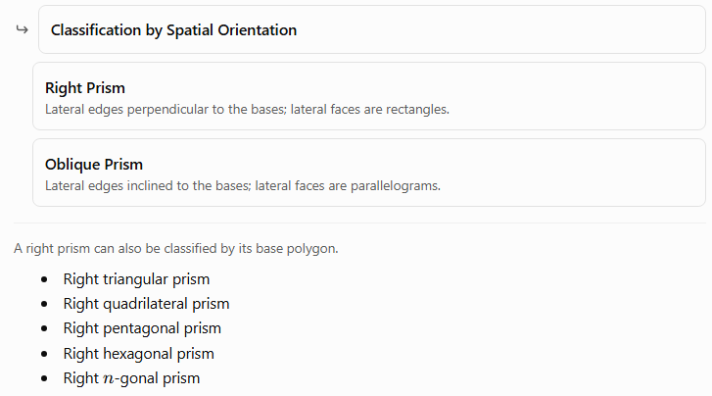
Classification by Spatial Orientation
Right Prism
Lateral edges perpendicular to the bases; lateral faces are rectangles.
Oblique Prism
Lateral edges inclined to the bases; lateral faces are parallelograms.
A right prism can also be classified by its base polygon.
- Right triangular prism
- Right quadrilateral prism
- Right pentagonal prism
- Right hexagonal prism
- Right $n$-gonal prism

Key Characteristics
# Source: AI Source: Provided by: [Data Path: Persons Table -> ID Column: 1, Name_En Column: Motasem Essam] -> From: [ChatGPT] on [7/25/2026]
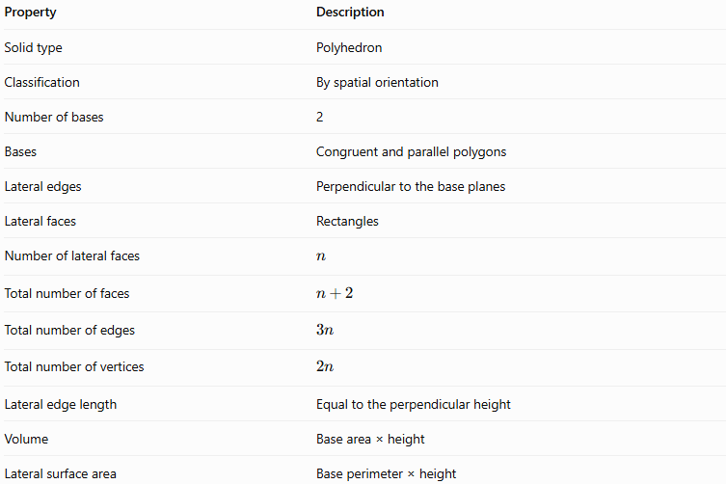
Property | Description
Solid type | Polyhedron
Classification | By spatial orientation
Number of bases | 2
Bases | Congruent and parallel polygons
Lateral edges | Perpendicular to the base planes
Lateral faces | Rectangles
Number of lateral faces | $$n$$
Total number of faces | $$n+2$$
Total number of edges | $$3n$$
Total number of vertices | $$2n$$
Lateral edge length | Equal to the perpendicular height
Volume | Base area × height
Lateral surface area | Base perimeter × height
Here, $n$ is the number of sides of each base polygon.

Geometric Representation
# Source: AI Source: Provided by: [Data Path: Persons Table -> ID Column: 1, Name_En Column: Motasem Essam] -> From: [ChatGPT] on [7/25/2026]
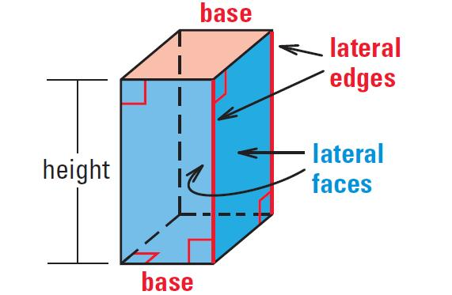
The principal components of a right prism are:
- Base faces: Two congruent, parallel polygons.
- Lateral faces: Rectangles connecting corresponding sides of the bases.
- Base edges: The edges surrounding the two bases.
- Lateral edges: Edges connecting corresponding vertices of the bases.
- Vertices: Corner points where the edges meet.
- Height: The perpendicular distance between the two base planes.
The key geometric feature is that each lateral edge is perpendicular to the base planes. Therefore, the length of every lateral edge equals the height of the prism.

Mathematical Representations and Formulas
# Source: AI Source: Provided by: [Data Path: Persons Table -> ID Column: 1, Name_En Column: Motasem Essam] -> From: [ChatGPT] on [7/25/2026]
Let:
- $n$ = number of sides of the base polygon.
- $B$ = area of one base.
- $p$ = perimeter of the base.
- $h$ = height of the prism.
- $A_{L}$ = lateral surface area.
- $A_{T}$ = total surface area.
- $V$ = volume.

A. Number of faces, edges, and vertices
# Source: AI Source: Provided by: [Data Path: Persons Table -> ID Column: 1, Name_En Column: Motasem Essam] -> From: [ChatGPT] on [7/25/2026]
For an $n$-gonal prism:
$$\boxed{F=n+2}$$
$$\boxed{E=3n}$$
$$\boxed{V_{​e}=2n}$$
Here, $V_{​e}$ denotes the number of vertices, distinguishing it from the volume $V$.
These formulas apply to both right and oblique prisms.

B. Volume
# Source: AI Source: Provided by: [Data Path: Persons Table -> ID Column: 1, Name_En Column: Motasem Essam] -> From: [ChatGPT] on [7/25/2026]
The volume of a right prism is the area of its base multiplied by its height:
$$\boxed{V=Bh}$$

C. Lateral surface area
# Source: AI Source: Provided by: [Data Path: Persons Table -> ID Column: 1, Name_En Column: Motasem Essam] -> From: [ChatGPT] on [7/25/2026]
Each lateral face is a rectangle. Adding the areas of all lateral faces gives:
$$\boxed{A_{L}=ph}$$
This formula works because each rectangle has a height equal to the prism height, and the sum of its widths equals the base perimeter.

D. Total surface area
# Source: AI Source: Provided by: [Data Path: Persons Table -> ID Column: 1, Name_En Column: Motasem Essam] -> From: [ChatGPT] on [7/25/2026]
The total surface area includes the lateral faces and both bases:
$$A_{T}=A_{L}+2B$$
Therefore:
$$\boxed{A_{T}=ph+2B}$$

E. Euler’s formula
# Source: AI Source: Provided by: [Data Path: Persons Table -> ID Column: 1, Name_En Column: Motasem Essam] -> From: [ChatGPT] on [7/25/2026]
For a convex polyhedron:
$$V_{​e}-E+F=2$$
Substituting the prism formulas:
$$2n-3n+\left(n+2\right)=2$$
Thus, Euler’s formula holds for every convex right prism.

Types of Right Prisms by Base Shape

Right triangular prism
# Source: AI Source: Provided by: [Data Path: Persons Table -> ID Column: 1, Name_En Column: Motasem Essam] -> From: [ChatGPT] on [7/25/2026]
Has two congruent triangular bases and three rectangular lateral faces.
5 faces · 9 edges · 6 vertices
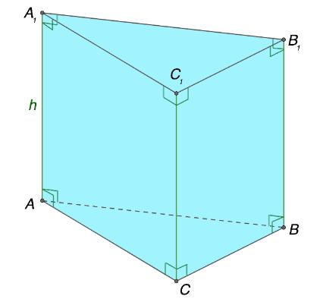

Right quadrilateral prism
# Source: AI Source: Provided by: [Data Path: Persons Table -> ID Column: 1, Name_En Column: Motasem Essam] -> From: [ChatGPT] on [7/25/2026]
Has two congruent quadrilateral bases and four rectangular lateral faces. A rectangular base produces a rectangular prism, also called a cuboid in the right-prism case.
6 faces · 12 edges · 8 vertices
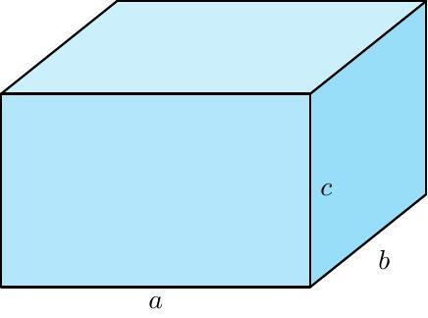

Right pentagonal prism
# Source: AI Source: Provided by: [Data Path: Persons Table -> ID Column: 1, Name_En Column: Motasem Essam] -> From: [ChatGPT] on [7/25/2026]
Has two congruent pentagonal bases and five rectangular lateral faces.
7 faces · 15 edges · 10 vertices

Right hexagonal prism
# Source: AI Source: Provided by: [Data Path: Persons Table -> ID Column: 1, Name_En Column: Motasem Essam] -> From: [ChatGPT] on [7/25/2026]
Has two congruent hexagonal bases and six rectangular lateral faces.
8 faces · 18 edges · 12 vertices
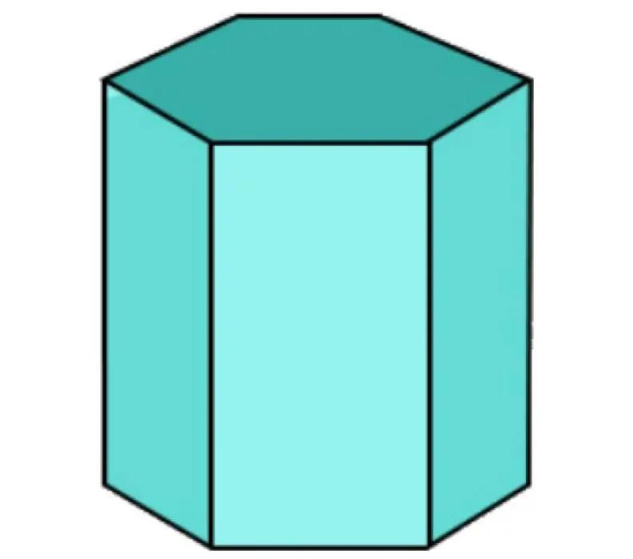

Worked Examples
# Source: AI Source: Provided by: [Data Path: Persons Table -> ID Column: 1, Name_En Column: Motasem Essam] -> From: [ChatGPT] on [7/25/2026]
Example 1: Counting faces, edges, and vertices
Problem: A right pentagonal prism has bases with five sides each. Find its number of faces, edges, and vertices.
Given $n=5$:
$$F=n+2=5+2=7$$
$$E=3n=3\left(5\right)=15$$
$$V_{​e}=2n=2\left(5\right)=10$$
Answer: 7 faces, 15 edges, and 10 vertices.
Example 2: Calculating volume
Problem: A right prism has a base area of $42{\text{ cm}}^{2}$ and a height of $8\text{ cm}$. Find its volume.
$$V=Bh$$
$$V=42\left(8\right)$$
$$\boxed{V=336{\text{ cm}}^{3}}$$
Example 3: Calculating lateral surface area
Problem: A right prism has a base perimeter of $30\text{ cm}$ and a height of $12\text{ cm}$. Find its lateral surface area.
$$A_{L}=ph$$
$$A_{L}=30\left(12\right)$$
$$\boxed{A_{L}=360{\text{ cm}}^{2}}$$
Example 4: Calculating total surface area
Problem: A right prism has a base area of $25{\text{ cm}}^{2}$, a base perimeter of $24\text{ cm}$, and a height of $7\text{ cm}$. Find its total surface area.
First, calculate the lateral surface area:
$$A_{L}=ph=24\left(7\right)=168{\text{ cm}}^{2}$$
Then add both bases:
$$A_{T}=A_{L}+2B$$
$$A_{T}=168+2\left(25\right)$$
$$\boxed{A_{T}=218{\text{ cm}}^{2}}$$
Example 5: Verifying Euler’s formula
Problem: Verify Euler’s formula for a right hexagonal prism.
For $n=6$:
$$V_{​e}=12, E=18, F=8$$
Substitute:
$$V_{​e}-E+F=12-18+8=2$$
Answer: Euler’s formula is satisfied.

Comparison with an Oblique Prism
# Source: AI Source: Provided by: [Data Path: Persons Table -> ID Column: 1, Name_En Column: Motasem Essam] -> From: [ChatGPT] on [7/25/2026]
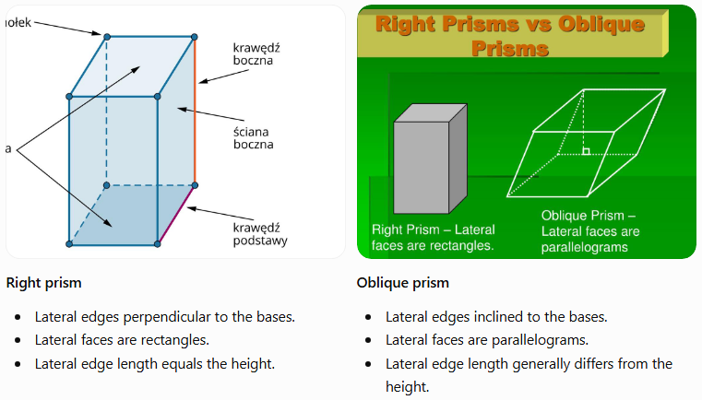
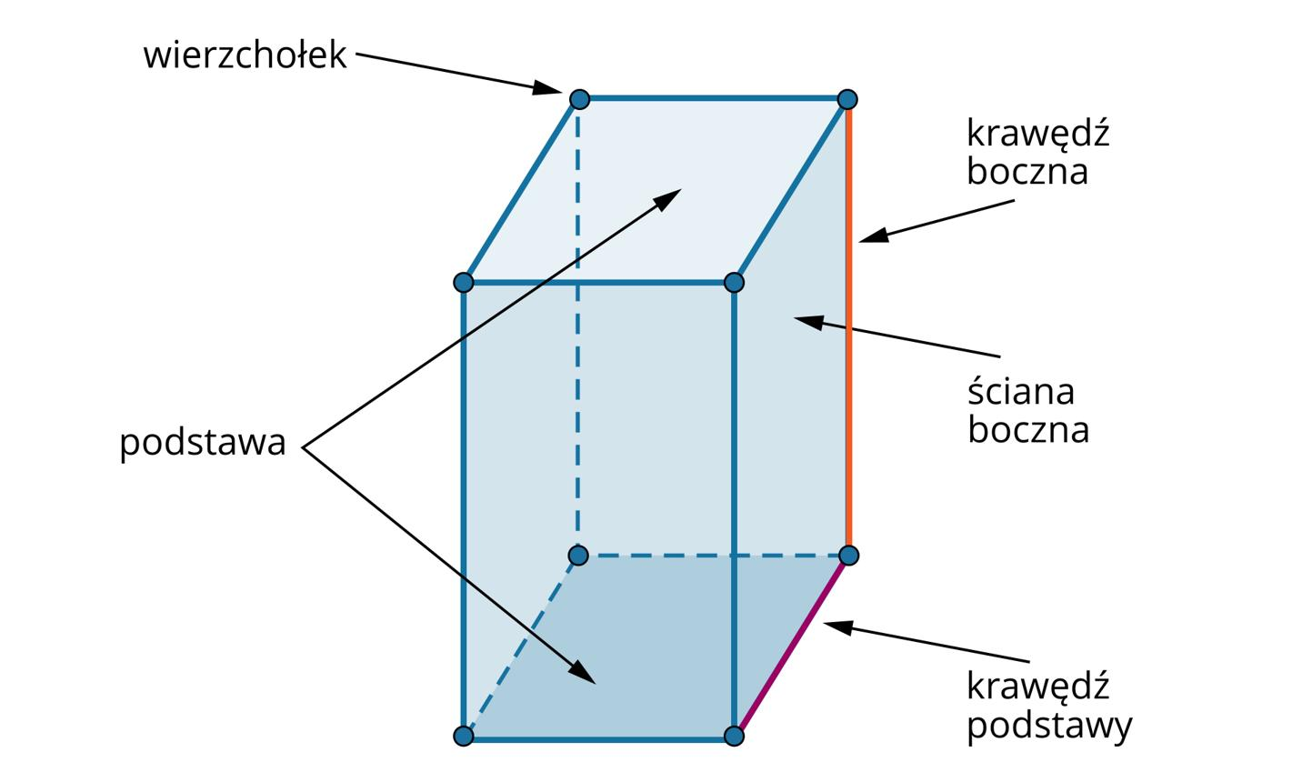
Right prism
- Lateral edges perpendicular to the bases.
- Lateral faces are rectangles.
- Lateral edge length equals the height.
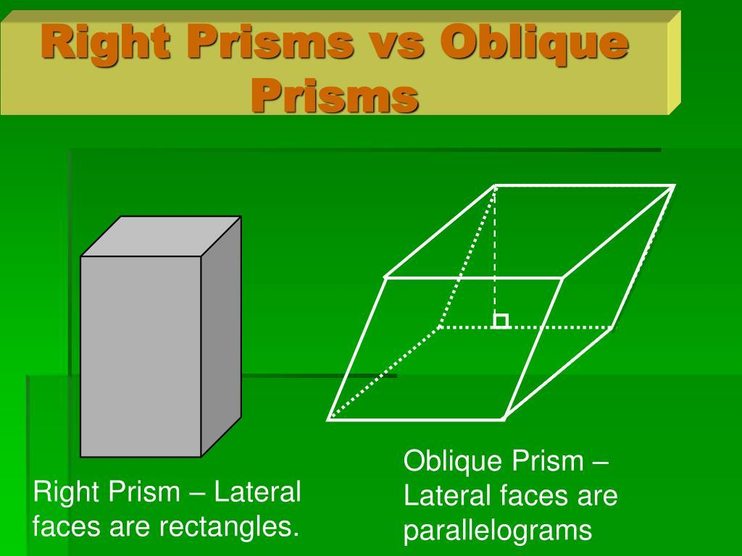
Oblique prism
- Lateral edges inclined to the bases.
- Lateral faces are parallelograms.
- Lateral edge length generally differs from the height.
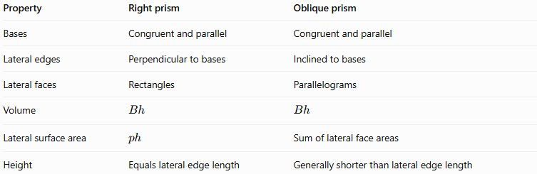
Property | Right prism | Oblique prism
Bases | Congruent and parallel | Congruent and parallel
Lateral edges | Perpendicular to bases | Inclined to bases
Lateral faces | Rectangles | Parallelograms
Volume | $$Bh$$ | $$Bh$$
Lateral surface area | $$ph$$ | Sum of lateral face areas
Height | Equals lateral edge length | Generally shorter than lateral edge length
Both types have the same number of faces, edges, and vertices when their bases have the same polygonal shape.

Applications
# Source: AI Source: Provided by: [Data Path: Persons Table -> ID Column: 1, Name_En Column: Motasem Essam] -> From: [ChatGPT] on [7/25/2026]
Architecture and construction
Right prisms model upright columns, rectangular building components, and structural elements with perpendicular sides.

Packaging and manufacturing
Their regular geometry simplifies calculations of volume, surface area, and the amount of material needed.
Mathematics and computer graphics
Right prisms are useful for learning spatial geometry and constructing 3D models with parallel bases and perpendicular side edges.

Key Points
# Source: AI Source: Provided by: [Data Path: Persons Table -> ID Column: 1, Name_En Column: Motasem Essam] -> From: [ChatGPT] on [7/25/2026]
- A right prism has two congruent, parallel polygonal bases.
- Its lateral edges are perpendicular to the base planes.
- Its lateral faces are rectangles.
- For an $n$-gonal right prism, $F=n+2$, $E=3n$, and $V_{​e}=2n$.
- Its volume is $V=Bh$.
- Its lateral surface area is $A_{L}=ph$.
- Its total surface area is $A_{T}=ph+2B$.
- A right prism can have any polygonal base; right describes orientation, not base shape.

Conclusion
# Source: AI Source: Provided by: [Data Path: Persons Table -> ID Column: 1, Name_En Column: Motasem Essam] -> From: [ChatGPT] on [7/25/2026]
A right prism is defined by the perpendicular orientation of its lateral edges relative to its bases. This creates rectangular lateral faces and makes its surface-area calculations straightforward. Its base may be any polygon, and the general formulas for faces, edges, vertices, volume, and surface area apply across all right-prism types.

